
X
X
X
TYPE HERE
TYPE HERE
TYPE HERE
TYPE HERE
TYPE HERE
TYPE HERE

TYPE HERE

TYPE HERE
TYPE HERE
TYPE HERE
TYPE HERE
TYPE HERE
TYPE HERE
TYPE HERE
TYPE HERE
TYPE HERE
TYPE HERE
TYPE HERE
TYPE HERE
TYPE HERE
TYPE HERE
TYPE HERE
X
X
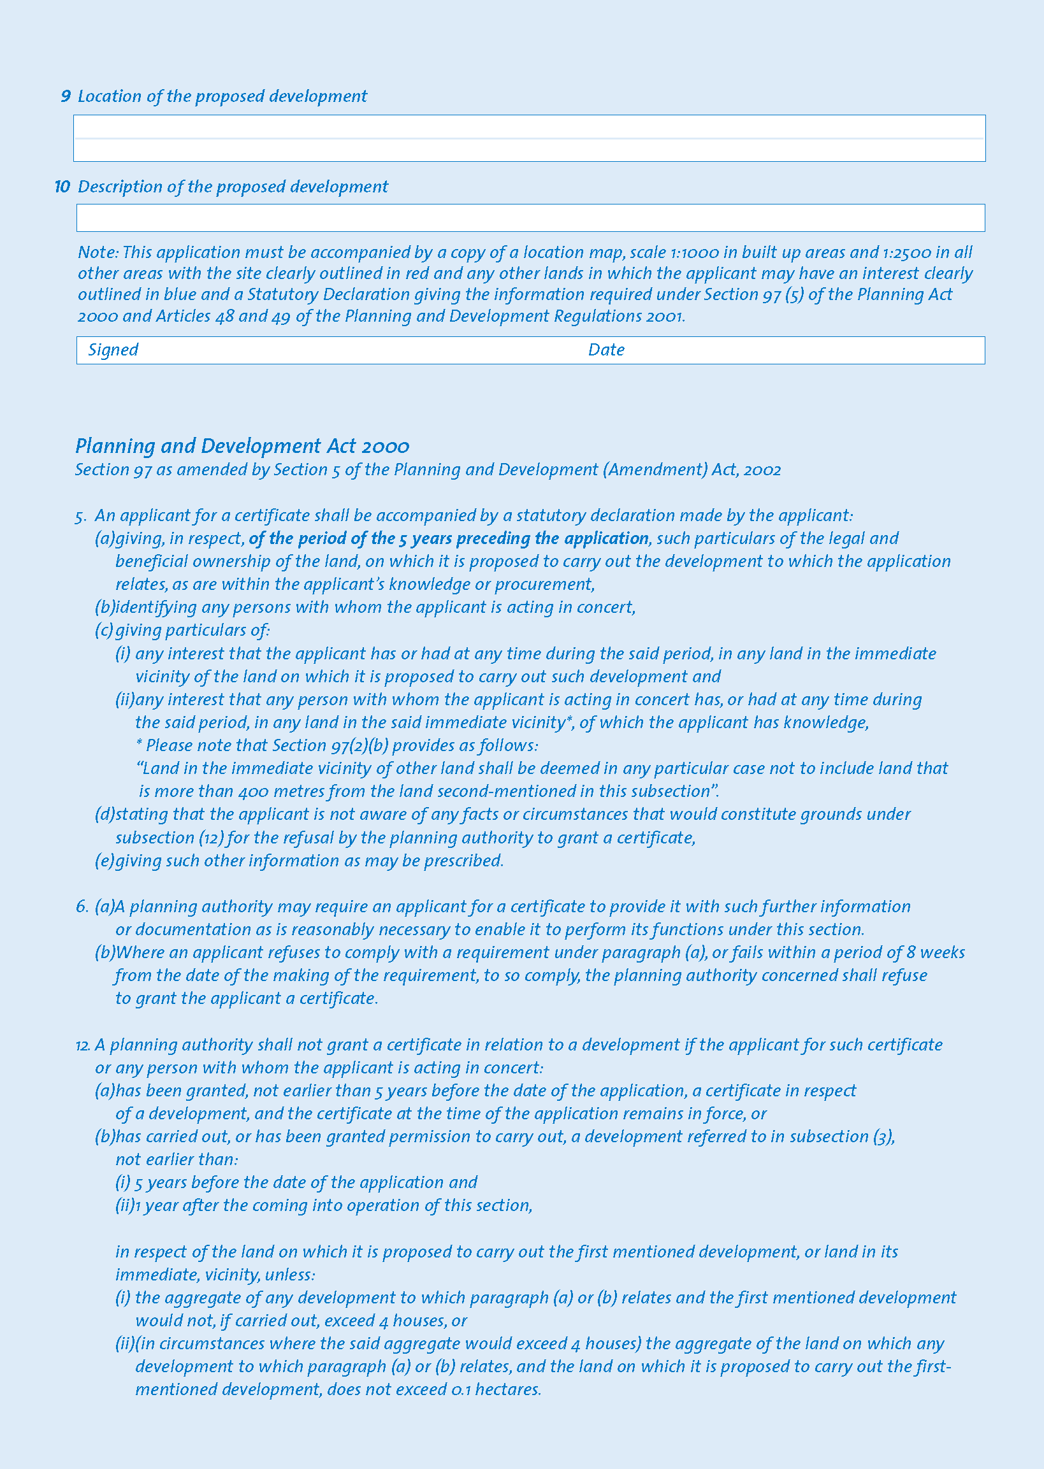
TYPE HERE
TYPE HERE
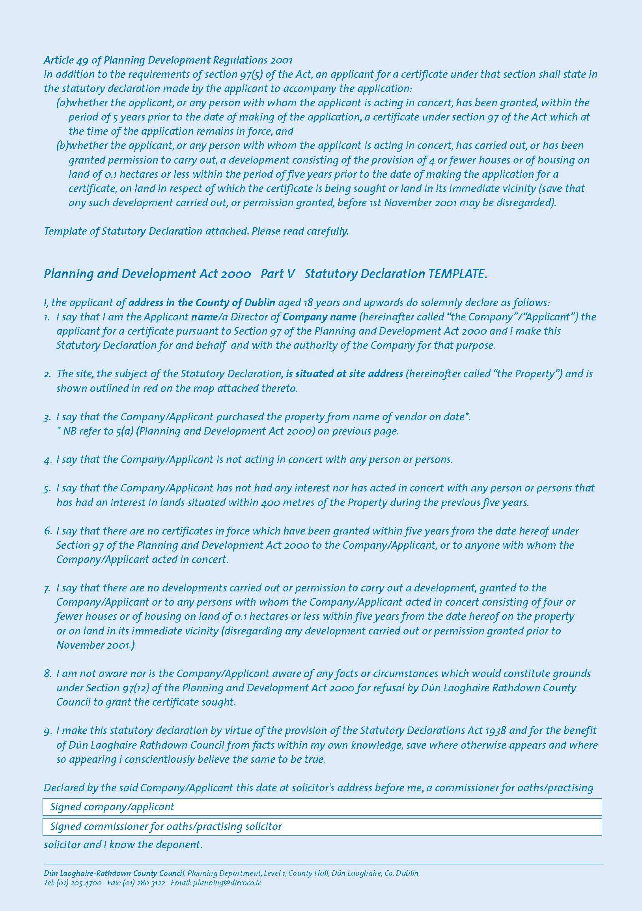
TYPE HERE
TYPE HERE
TYPE HERE
TYPE HERE

TYPE HERE
TYPE HERE
TYPE HERE
TYPE HERE
TYPE HERE
TYPE HERE

TYPE HERE

